Shane Bolding

[Shb7@students.uwf.edu](mailto:Shb7@students.uwf.edu)

EEL4744L: Microprocessor Lab

Lab 3: Writing and Testing A Simple Program

9-1-19

**Objectives:**

The object of this lab is as the title of the lab suggests. We are writing and testing a simple program in order to begin to understand the basics of assembly and how to test it. We are going to achieve this by writing an assembly code and testing it with Buffalo I/O routines to verify and display the results on the screen.

**Introduction:**

To do this lab we will be using the MC68HC11 EVBU kit to test our code. This board has programmable memory that we can use to store our assembly program. This allows for us to communicate to the board via a software on the computer and test the assembly program using Buffalo. To perform this lab, we will also need to know how to multiply hexadecimal numbers. Lucky for us to multiply hexadecimal is the same as multiplying in decimal. That is, we multiply the lowest two bytes of the multiplicand and multiplier together to get a 2-byte answer. Then we multiply the lowest byte of the multiplier with the next byte to the left of the multiplicand to get another 2-byte answer; however, this time we make this value equivalent to shifting left a byte. You can repeat this as much times as needed and once done add all the products up to get your final product.

**Procedure:**

We need to write a program that multiplies a 3-byte number with a 1-byte number and produces the results. Buy following the steps in the lab handout one can come up with the code as follows. Notice each step that is listed in the lab is shown as a comment in the code.

*Program SHB&

*Multiplies 3byte by a 1byte

*Declares variables

ORG $00

M RMB 3

N RMB 1

P RMB 4

P1 RMB 2

P2 RMB 2

P3 RMB 2

*load A and B with LSB of both Multiplicand and Multiplier

LDAA $02

LDAB $03

*Multiplies A and B and stores in D

MUL

*Store B into LSB of Product

STAB $07

*Store A into MSB of P1

STAA P1

*load the middle byte of Multiplicand to A

LDAA $01

*load multiplier into B

LDAB $03

*Multiply A and B and store into D

MUL

*Store D into P2

STD P2

*Read MSB of Multiplicand to A

LDAA $00

*Multiplier to B

LDAB $03

*multiply and store into P3

MUL

STD P3

*Load MSB of P1 into A

LDAA P1

*Load LSB of P2 into B

LDAB P2+1

*Add A and B into mid byte low of product

ABA

STAA $06

*Put MSB of P2 into A

LDAA P2

*Add with carry P3 LSB with A

ADCA P3+1

*Store sum into mid byte high of product

STAA $05

*P3 MSB to A

LDAA P3

*Add w/ carry zero

ADCA 0

*Store sum to product MSB

STAA $04

Programming the code into the board we can now use the software on the computer to test our code. Looking below this shows that we can multiply $12 and $98. We can do this by using the command mm which is the memory management command. This allows us to change the value of the memory to be what we need it to be. In this case $12 and $98.

The next picture shows the results of $DA multiplied by $BA.

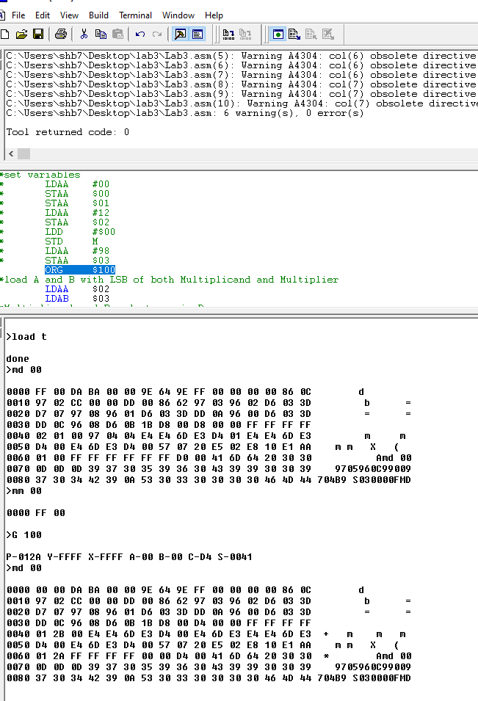

**Conclusion:**